Lecture 1: Introduction to OpenMP & Shared Memory Model
🎯 Lecture Objectives
- Introduce the concept of parallel computing.
- Explain shared memory architecture.
- Introduce OpenMP as a tool for shared memory programming.
✅ Learning Outcomes
By the end of this lecture, students will be able to:
- Understand the need for parallel computing in modern applications.
- Describe the architecture and behavior of shared memory systems.
- Identify the role and structure of OpenMP in high-performance computing.

🧠 1. Introduction to Parallel Computing
Definition:
Parallel computing is a type of computation where many calculations or processes are carried out simultaneously, leveraging multiple processing elements.
Why Parallel Computing?
- Speed up execution of programs
- Handle large-scale problems (e.g., simulation, ML)
- Efficient use of modern multi-core CPUs and GPUs
Types of Parallelism:
- Data Parallelism – Distributing data across multiple threads
- Task Parallelism – Distributing tasks or functions

🖥️ 2. Shared Memory Architecture
In a shared memory system, multiple processors (or threads) access a common memory space.
Diagram:
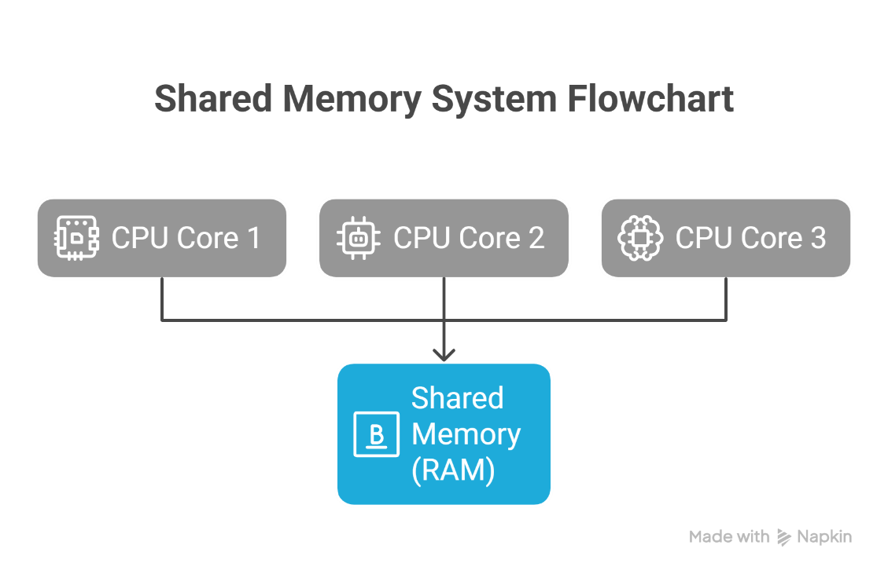
Key Characteristics:
- Fast communication between threads
- Synchronization required to avoid race conditions
- Memory is shared, not copied → efficient memory usage
Examples:
- Multi-core CPUs (Intel i5, AMD Ryzen)
- Used in desktop machines and servers

💡 3. What is OpenMP?
OpenMP (Open Multi-Processing) is an API for parallel programming in C, C++, and Fortran using shared memory.
- Developed by a group of hardware/software vendors
- Allows easy parallelism with compiler directives (pragmas)
- No need to rewrite entire code; just annotate

🔧 4. Key Components of OpenMP
Component | Description
Compiler Directives | #pragma omp ... – Special instructions to compiler
Runtime Library Routines | Functions like omp_get_thread_num()
Environment Variables | Control behavior like number of threads (OMP_NUM_THREADS)

🧪 5. Example: Hello World with Threads
Code Example:
#include <stdio.h>
#include <omp.h>

int main() {
#pragma omp parallel
{
int tid = omp_get_thread_num(); // Thread ID
printf("Hello from thread %d\n", tid);
}
return 0;
}
Expected Output (unordered):
Hello from thread 0
Hello from thread 1
Hello from thread 2
Hello from thread 3
Explanation:
- #pragma omp parallel creates multiple threads.
- Each thread runs the block inside {}.
- omp_get_thread_num() returns the thread's unique ID.

🚧 6. Challenges in Shared Memory Programming
- Race Conditions: Multiple threads accessing/modifying the same data
- Synchronization: Must control access using critical sections or atomic operations
- Scalability: Limited by number of cores and memory bandwidth

🧩 Classroom Activity
🔸 Ask students to write a small OpenMP program to compute the sum of thread IDs.
🔸 Discuss output and how memory is shared.

📋 Summary
- Parallel computing improves performance by dividing tasks.
- Shared memory models allow threads to access common data.
- OpenMP simplifies parallel programming through compiler directives

Classroom Activity in Detail
Topic: Compute the sum of thread IDs using OpenMP
Objective:
- Help students understand thread-level execution
- Show how shared variables are accessed and updated in a parallel region
- Demonstrate potential race conditions and importance of synchronization

🎯 Task for Students
Write an OpenMP program that:
- Spawns multiple threads using a parallel region
- Each thread gets its own thread ID
- Each thread adds its ID to a shared variable sum

🧾 Example Program Without Synchronization
#include <stdio.h>
#include <omp.h>

int main() {
int sum = 0;

#pragma omp parallel
{
int tid = omp_get_thread_num();
sum += tid; // Race condition likely!
}

printf("Sum of thread IDs = %d\n", sum);
return 0;
}

⚠️ Expected Output (Incorrect or Unstable)
Sum of thread IDs = 3 // Sometimes correct
Sum of thread IDs = 2 // Sometimes wrong!
Sum of thread IDs = 1 // Varies per execution
Why?
- Multiple threads try to read and write to the variable sum simultaneously
- This causes a race condition—threads interrupt each other unpredictably

✅ Corrected Version With Synchronization
#include <stdio.h>
#include <omp.h>

int main() {
int sum = 0;

#pragma omp parallel
{
int tid = omp_get_thread_num();

#pragma omp critical
{
sum += tid; // Only one thread updates at a time
}
}

printf("Correct Sum of thread IDs = %d\n", sum);
return 0;
}

✅ Alternative Using Reduction Clause
#include <stdio.h>
#include <omp.h>

int main() {
int sum = 0;

#pragma omp parallel reduction(+:sum)
{
int tid = omp_get_thread_num();
sum += tid;
}

printf("Sum of thread IDs using reduction = %d\n", sum);
return 0;
}
Advantages of reduction:
- Simpler and more efficient than critical
- Automatically handles local copies and combines them at the end

📚 Discussion Points for Classroom
- How threads share and modify the same memory?
  - The variable sum is in shared memory
  - All threads can read/write unless controlled
- What is a race condition?
  - Occurs when two or more threads read/write a variable at the same time
  - Output becomes non-deterministic
- How to avoid it?
  - Use critical sections for mutual exclusion
  - Use reduction clause for safe accumulation
- Why does reduction work better?
  - Compiler manages local and final sums
  - No need for manual synchronization

🔍 Sample Output With 4 Threads
Correct Output (Thread IDs: 0, 1, 2, 3):
Sum of thread IDs = 6
Calculation:
0 + 1 + 2 + 3 = 6

🧪 Extension Task (Optional)
Challenge students to:
- Try the same task without omp_get_thread_num()—why is it needed?
- Print values of sum inside and outside the parallel block

